Global Terrorism Database

#### ***Prabhath D, Marvel, Praful Dev, Manpreet Kaur, Pavan shankara***

#### ***4 September 2018***

no_attacks_year = all_data %>% group_by(iyear) %>% summarise(Total_attacks = n())  
  
ggplot(no_attacks_year, aes(iyear, Total_attacks)) + geom_point(color = 'blue') + geom_line() +   
 scale_x_continuous(breaks = seq(1970, 2015, 1)) +   
 scale_y_continuous(breaks = seq(0, 20000, 1000))+ theme(axis.text.x = element_text(angle = 90)) +   
 labs(title = "Total Attacks Per Year", x = "Year" , y = "Total Attacks")

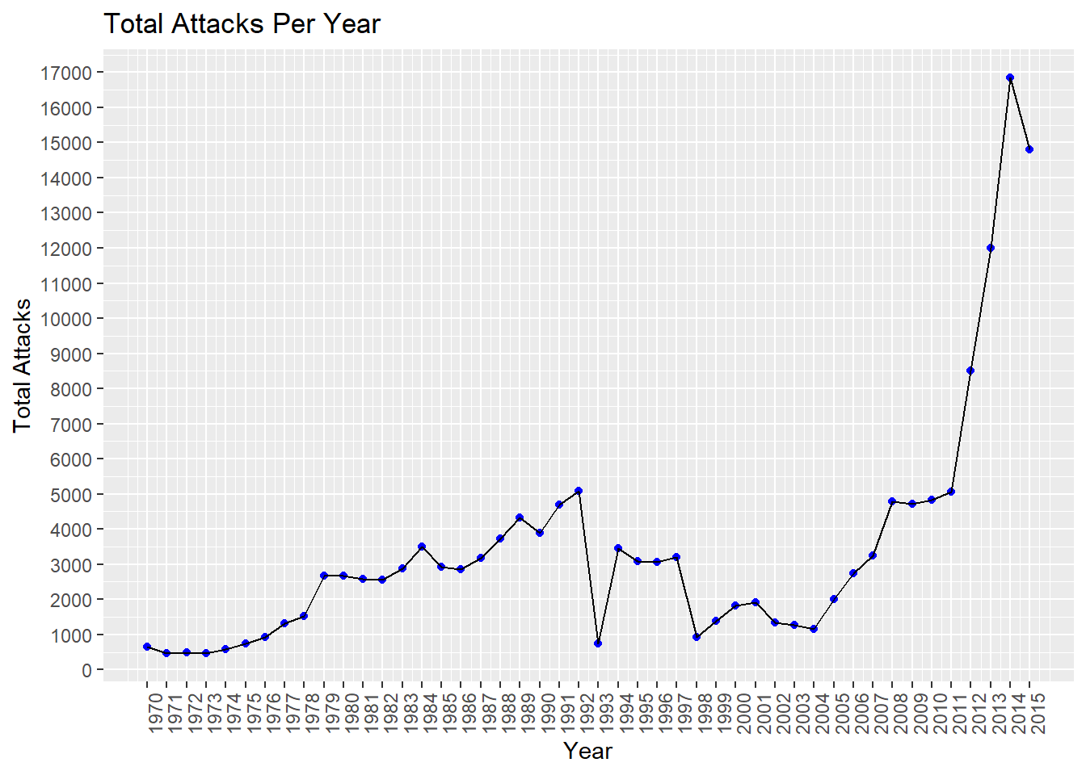

bombings_per_year = all_data %>%   
 filter(attacktype1_txt == 'Bombing/Explosion') %>%   
 group_by(iyear) %>% summarise(Total = n())

## Warning: package 'bindrcpp' was built under R version 3.4.4

ggplot(bombings_per_year, aes(iyear, Total)) + geom_point(color = 'Blue') + geom_line() + scale_x_continuous(breaks = seq(1970, 2015, 1)) +   
 scale_y_continuous(breaks = seq(0, 20000, 1000))+ theme(axis.text.x = element_text(angle = 90)) +   
 labs(title = "Total Bombings Per Year", x = "Year" , y = "Total Bombings")

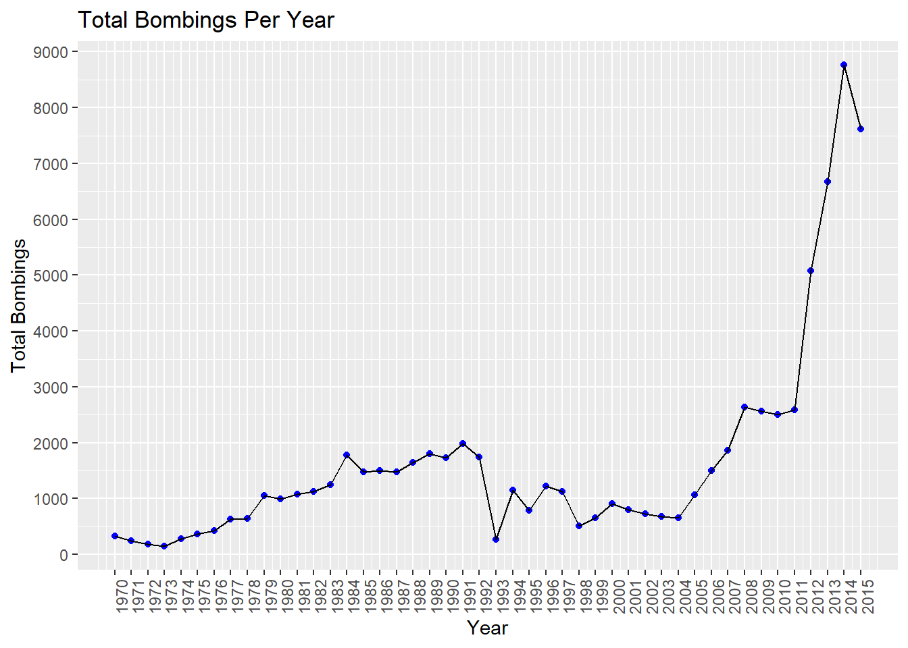

region_attacks_year = all_data %>% filter(iyear != 1993) %>% group_by(iyear,region_txt) %>% summarise(Total_attacks = n())  
  
ggplot(region_attacks_year, aes(iyear, Total_attacks)) + geom_area(aes(color = region_txt)) + theme_classic() +  
 facet_wrap(~region_txt, scales = 'free')+ scale_x_continuous(breaks = seq(1970, 2015, 5))+  
 theme(legend.position = 'none', axis.text.x = element_text(angle = 90))+  
 labs(title = 'Terrorist Attacks Region Wise For Year', x = 'Year', y = 'Total Attacks')

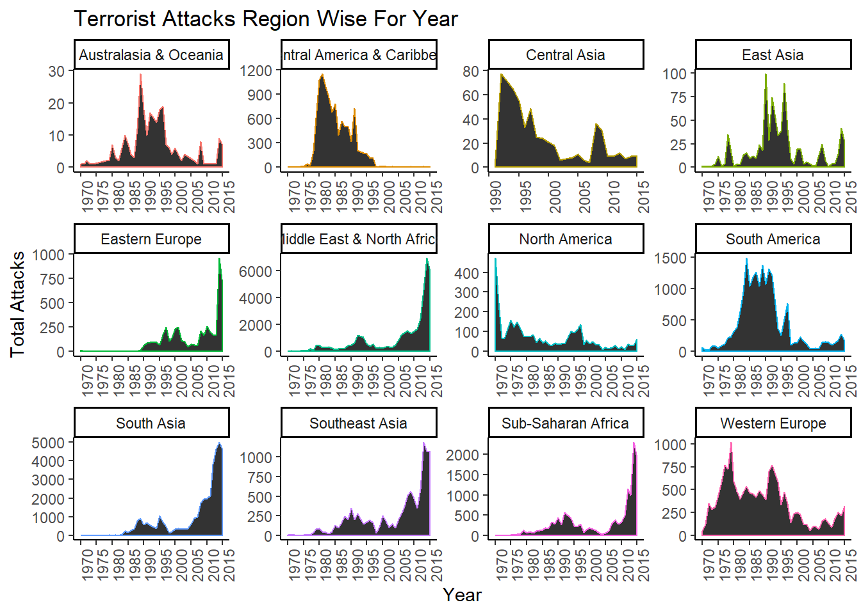

Top_attacks_region = all_data%>% filter(iyear != 1993) %>%group_by(region_txt, attacktype1_txt) %>% summarise(Total_attacks = n()) %>%  
 top_n(5)

## Selecting by Total_attacks

ggplot(Top_attacks_region, aes(attacktype1_txt, Total_attacks)) +   
 geom_bar(stat = 'identity', aes(fill =attacktype1_txt )) +  
 facet_wrap(~region_txt, scales = 'free') + geom_text(aes(label=Total_attacks),size=3, vjust=0.5)+  
 theme(legend.position = 'none', axis.text.x = element_blank(), axis.ticks.x = element_blank()) +   
 labs(title = 'Top 5 types of Terror Attacks Per Region', x = 'Attack Type', y = 'Total Attacks')

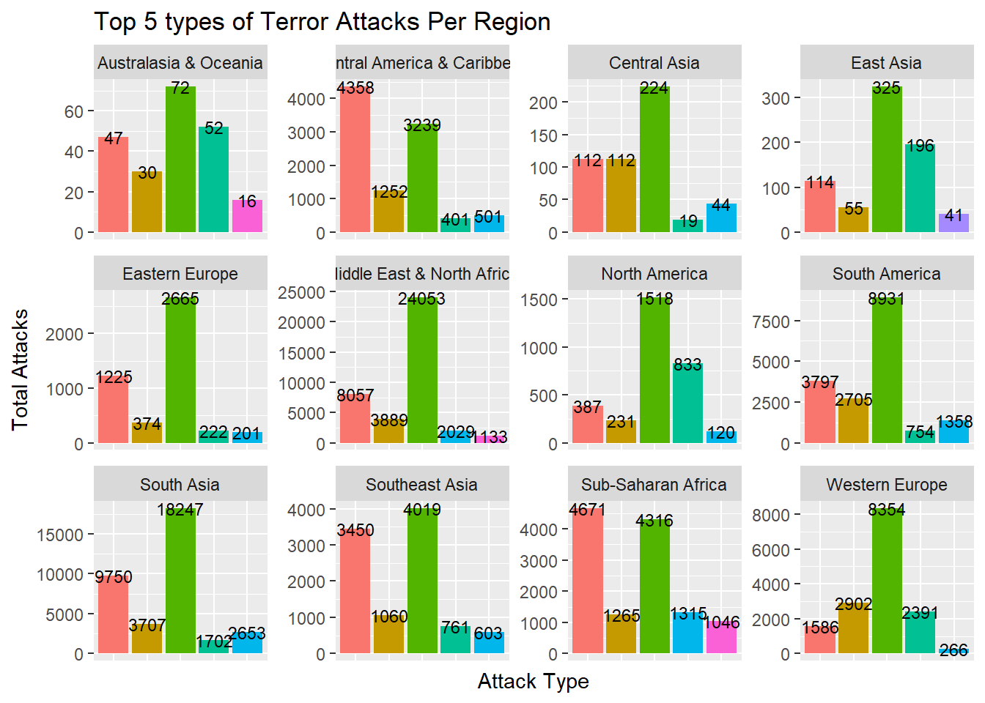

target_types = all_data %>% group_by(targtype1_txt) %>% summarise(Total = n())  
  
  
ggplot(target_types, aes(reorder(targtype1_txt, -Total), Total, fill = targtype1_txt)) +   
 geom_bar(stat = 'Identity', width = 0.2) +  
 geom_label(aes(label = Total), size = 2)+  
 theme(legend.position = 'bottom', axis.text.x = element_blank(), axis.ticks.x = element_blank()) +   
 scale_y_continuous(breaks = seq(0, 35000, 5000)) +  
 labs(title = "Heaviest Hit Target Types", x = 'Target Type', y = 'Total')

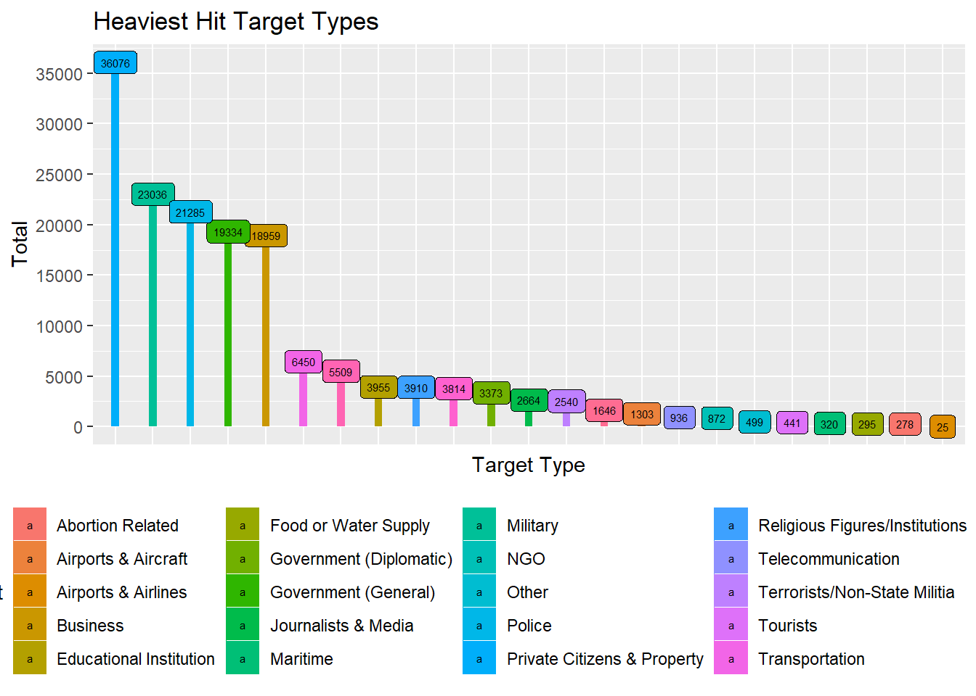

IndvsPak = all_data %>% filter(country_txt == 'India' | country_txt == 'Pakistan') %>%   
 group_by(iyear, country_txt) %>% summarise(Total = n())  
IndvsPak$country_txt = as.factor(IndvsPak$country_txt)  
  
ggplot(IndvsPak, aes(x= iyear, y= Total)) +  
 geom_area(stat = 'identity',colour="black", alpha=.5,aes(fill = country_txt)) + facet_grid(~country_txt)+  
 geom_point(size = 1.5, col = 'black')+ theme_bw() +   
 scale_x_continuous(breaks = seq(1970, 2015, 3)) +   
 scale_y_continuous(breaks = seq(0, 2500, 500)) +   
 theme(axis.text.x = element_text(angle = 90), legend.position = 'bottom') +   
 labs(title = 'Terrorist Attacks in India and Pakistan for last 45 Years', x = 'Year', y = 'Number Of Attacks')

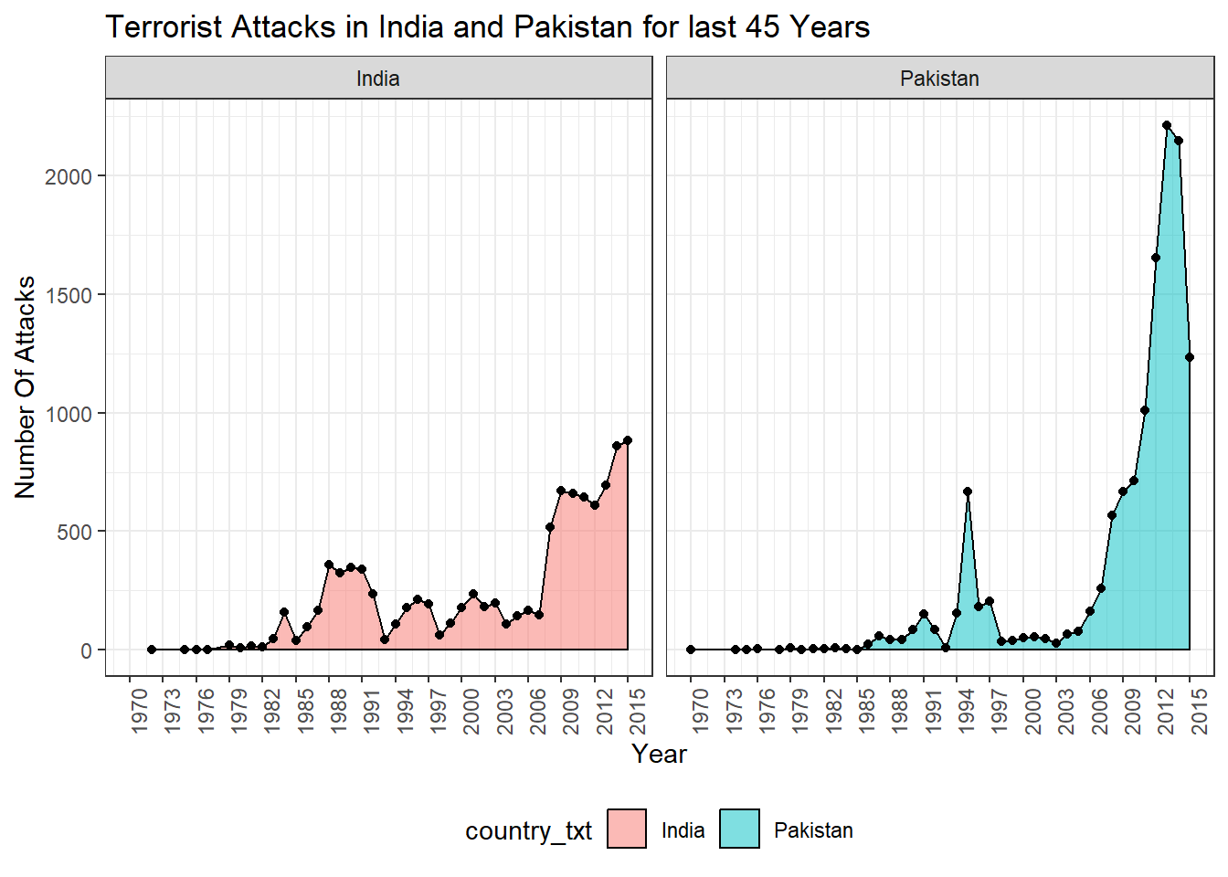 Terror attack in United States vs Russian Federation/USSR in last 45 years

USvsUSSR = all_data %>%   
filter(country_txt == 'Russia'|country_txt == 'Soviet Union' | country_txt == 'United States') %>%  
 group_by(iyear, country_txt) %>% summarise(Total = n())  
  
  
ggplot(USvsUSSR,aes(x=iyear, y=Total, group=country_txt)) +  
 geom_density(alpha=0.4,aes(fill=country_txt), stat = 'identity') +  
 geom_text(aes(label=Total),size=2.9, vjust=-1)+geom_point()+  
 theme_classic()+  
 scale_x_continuous(breaks = seq(1970, 2015, 3)) +   
 scale_y_continuous(breaks = seq(0, 2500, 500)) +   
 theme(axis.text.x = element_text(angle = 90), legend.position = 'bottom') +   
 labs(title = 'Terrorist Attacks in US and USSR for last 45 Years', x = 'Year', y = 'Number Of Attacks')

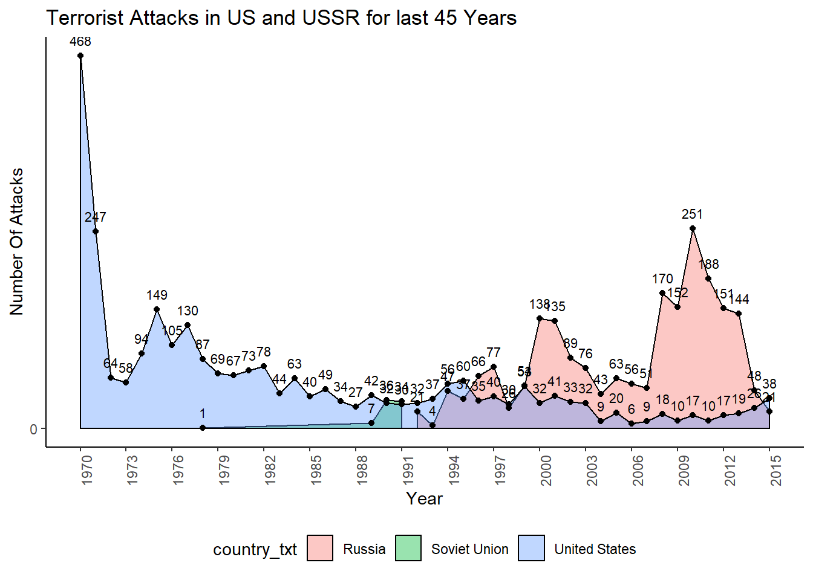

all_data[is.na(all_data$nkill),"nkill" ] = 0  
all_data[is.na(all_data$nwound),104 ] = 0  
all_data$casualties = all_data$nkill +all_data$nwound   
  
  
Most_casualties = all_data %>% group_by(country_txt) %>%   
 summarise(Total = sum(casualties )) %>% top_n(10, wt = Total)  
  
ggplot(Most_casualties, aes(reorder(country_txt, -Total), Total, fill = country_txt)) +   
 geom_bar(stat = 'Identity', width = 0.4,aes(fill = country_txt)) +   
 theme(legend.position = 'bottom', axis.text.x = element_blank(), axis.ticks.x = element_blank()) +   
 labs(title = 'Higest number of casualities(Counter Wise) ', x= element_blank(), y = 'NUmber of Casualities')+  
 scale_y_continuous(breaks = seq(0, 200000, 10000))

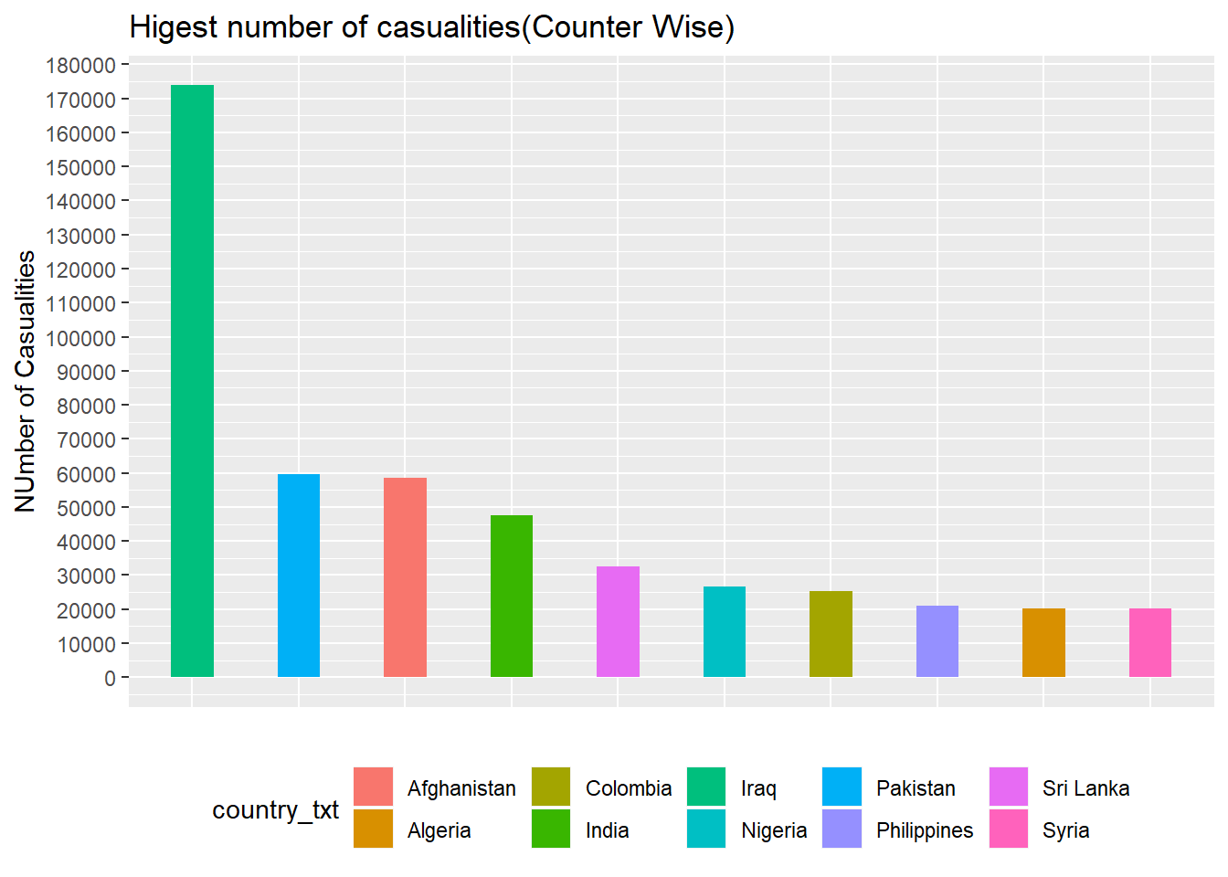

casualties_yearwise = all_data %>% group_by(iyear) %>% summarise(Total_casualities = round(sum(casualties)))  
  
  
ggplot(casualties_yearwise, aes(iyear, Total_casualities)) + geom_area(fill="red") + geom_point()+  
 scale_x_continuous(breaks = seq(1970, 2015, 3)) +   
 scale_y_continuous(breaks = seq(0, 85000, 10000)) +  
 theme(axis.text.x = element_text(angle = 90)) +   
 labs(title = 'Casualities through Years', x = 'Year', y = 'Number of Casualities') + theme_classic()

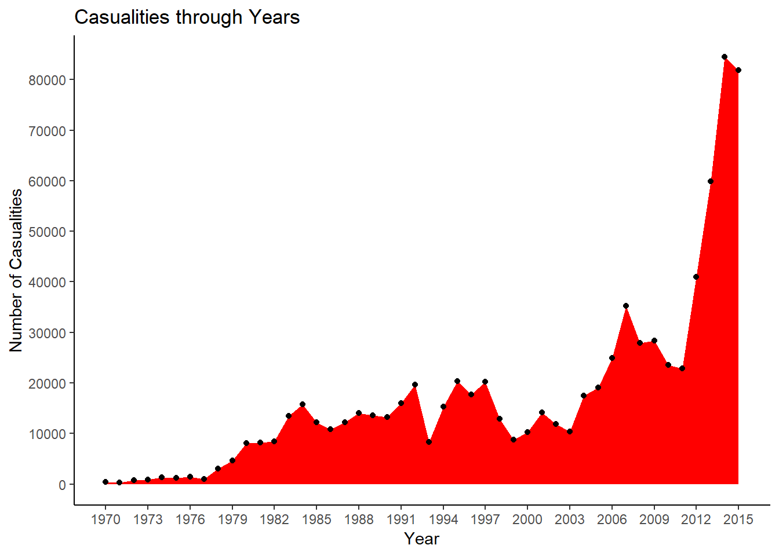

all_data[all_data$weaptype1_txt == 'Vehicle (not to include vehicle-borne explosives, i.e., car or truck bombs)', c(85)] = 'Vechicle'  
  
casualities_weapontype = all_data %>% group_by(weaptype1_txt) %>%   
 summarise(Total = round(sum(sum(nkill, nwound, na.rm = T))))  
  
  
ggplot(casualities_weapontype, aes(weaptype1_txt, Total, fill = weaptype1_txt)) +   
 geom_bar(stat = 'Identity', width = 0.2 ) +   
 theme_classic() + geom_label(aes(label = (weaptype1_txt))) +  
 theme(axis.text.x = element_blank(),legend.position = "none") +   
 scale_y_continuous(breaks = seq(0, 500000, 50000)) +   
 labs(title = 'Casualities by weapon type', x = 'Weapon Type', y = 'NUmber of Casualities')

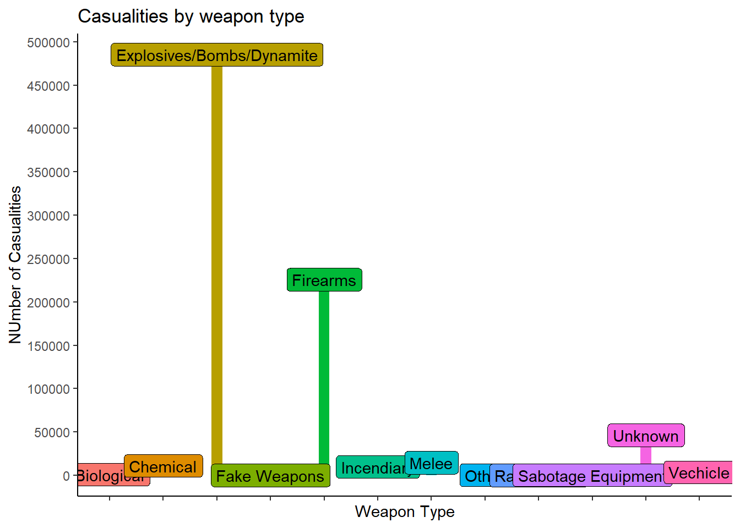

Top_Target_nations = all_data %>% group_by(natlty1_txt) %>% summarise(Total = n())   
  
Top_Target_nations$percentage = round(Top_Target_nations$Total/sum(Top_Target_nations$Total) *100, 2)  
  
  
  
Top_Target_nations %>% top_n(10, wt = Total) %>%   
ggplot( aes(reorder(natlty1_txt, -Total), Total, fill = natlty1_txt)) + theme_classic()+  
 geom_bar(stat = 'Identity', width = 0.1) + geom_label(aes(label = percentage)) +  
 theme(legend.position = 'bottom', axis.text.x = element_blank(), axis.ticks.x = element_blank()) +   
 scale_y_continuous(breaks = seq(0, 18000, 2000)) +   
 labs(title = 'Most Targeted Nationalities in Percentage', x = 'Nationality', y = 'Total Attacks')

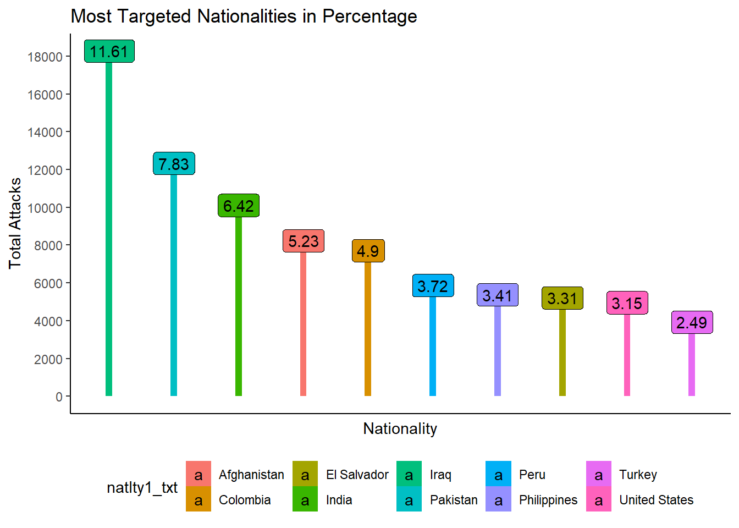

all_data$defend = ifelse(all_data$country_txt == all_data$natlty1_txt, 0, 1)  
e = all_data %>% group_by(natlty1_txt) %>% summarise(total = sum(defend))  
d = all_data %>% group_by(natlty1_txt) %>% summarise(total = n())  
f = merge(e,d, by = 'natlty1_txt')  
  
f$percent = f$total.x / f$total.y * 100  
  
all_data$out_of_country = ifelse(all_data$country_txt == all_data$natlty1_txt, 0, 1)  
  
j =all_data %>% filter(natlty1_txt == 'Romania') %>% group_by(natlty1_txt, out_of_country) %>% summarise(Total = n())  
  
a3 =ggplot(j,aes(as.factor(out_of_country), Total,fill = as.factor(out_of_country))) +   
 geom_bar(stat = 'identity', width = 0.2) + theme_classic() +   
 geom_label(aes(label = Total)) +  
 labs(title = 'Total number of attacks', x = 'Area of attack', y = 'Total Attacks')  
  
g = all_data %>% filter(country_txt == 'Romania' & doubtterr == 0)  
f = gather(g,type_of_casuality,no_casuality,nkill,nwound )  
  
a1 = ggplot(f,aes(type_of_casuality, no_casuality, fill =type_of_casuality )) + geom_bar(stat = 'identity') +  
 scale_y_continuous(breaks = seq(0, 9, 1))+  
 labs(title = 'Total number of attacks', x = 'Area of attack', y = 'Total Attacks')   
   
  
a2 = ggplot(g, aes(iyear, crit1, fill = as.factor(success))) + geom_bar(stat = 'identity')+  
 scale_x_continuous(breaks = seq(1970, 2015, 1)) +   
 scale_y_continuous(breaks = seq(0, 1, 1)) +  
 theme(axis.text.x = element_text(angle = 90), legend.position = 'bottom') +  
 labs(title = 'Total number of attacks', x = 'Year of Attack', y = 'Total Attacks')  
   
region_attacks_year1 = all_data %>% filter(iyear != 1993 & region_txt == 'Eastern Europe')%>% group_by(iyear,region_txt) %>% summarise(Total_attacks = n())  
  
a4 = ggplot(region_attacks_year1, aes(iyear, Total_attacks)) + geom_area(aes(color = region_txt)) + theme_classic() +  
 scale_x_continuous(breaks = seq(1970, 2015, 5))+  
 theme(legend.position = 'none', axis.text.x = element_text(angle = 90))+  
 labs(title = 'Terrorist Attacks Region Wise', x = 'Year', y = 'Total Attacks')  
grid.arrange(a3,a2,a1,a4)

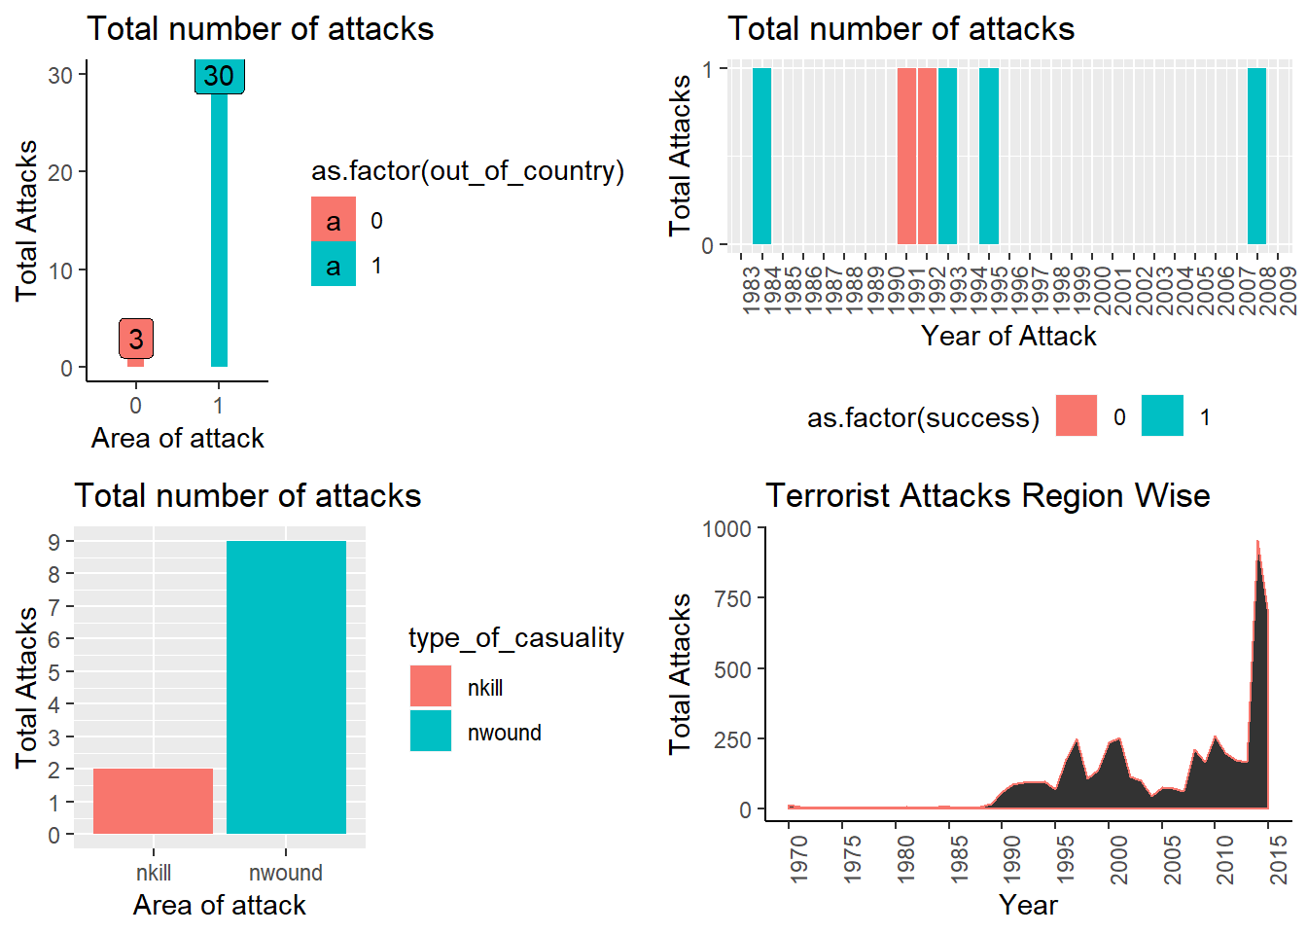

This is the nationality of the target that was attacked, and is not necessarily the same as the country in which the incident occurred, although in most cases it is.

Romania